# Run Visual Studio 2017

1. From top menu select *Team -> Manage Connections*

*Team Explorer – Connect* window should appear.

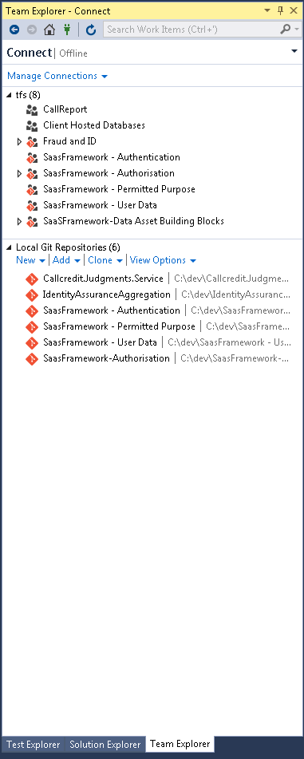

1. Click on *Manage Connections -> Connect to a Project*

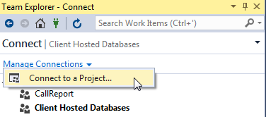

Similar window below should appear:

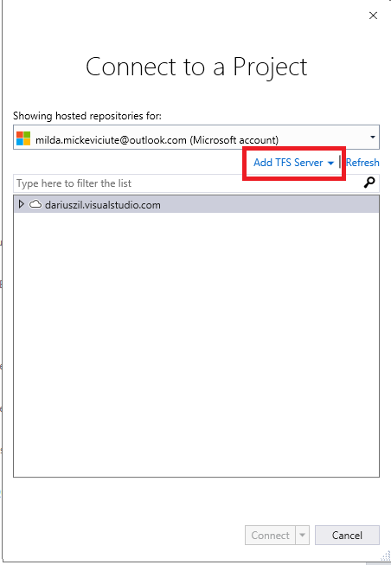

1. In case you do not have <http://tfs:8080/tfs> added as TFS Server then press *Add TFS Server* and write *tfs.* Press Add.

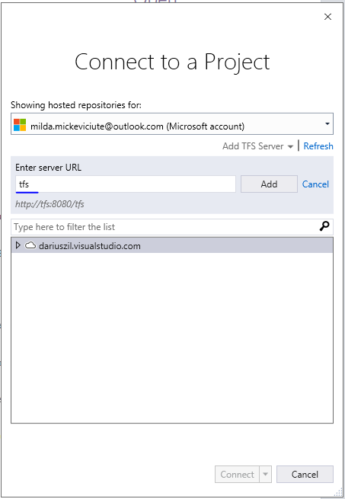

Server is added.

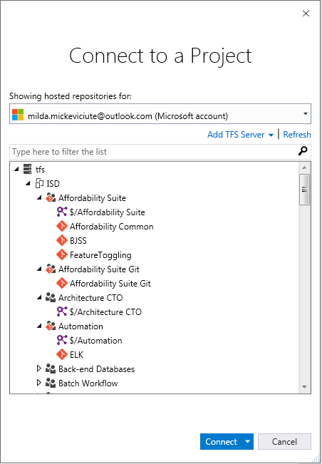

1. Select ISD, expand it. Scroll down till you see the **Client Hosted Databases** Repository.

Select the repository and press **Connect.**

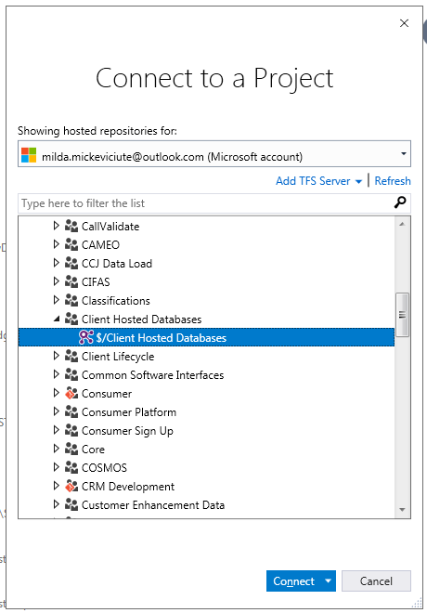

1. In *Team Explorer – Home Window* (*View -> Team Explorer*) select *Source Control Explorer*

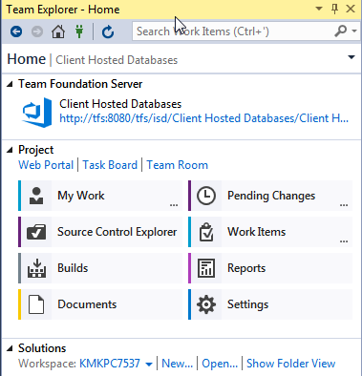

You should see window similar to the picture below:

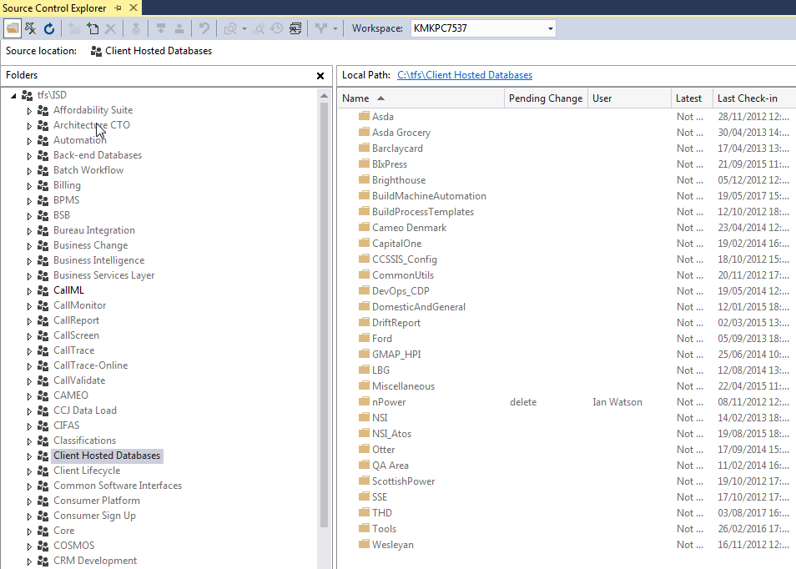

1. On the left-side expand *Client Hosted Databases -> QA Area -> 2 Trainings*
2. Right-click on the *SpecFlowDojo_DB* and select *Get Latest Version*

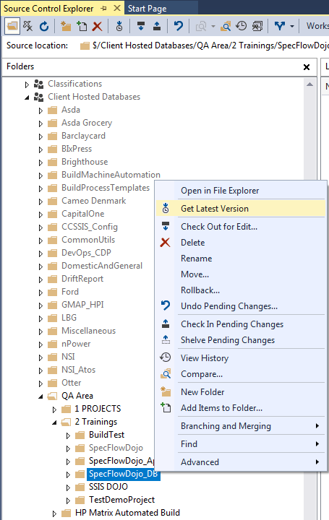

Wait till source will be downloaded locally.

1. Double click on *SpecFlowDojo_DB.sln*

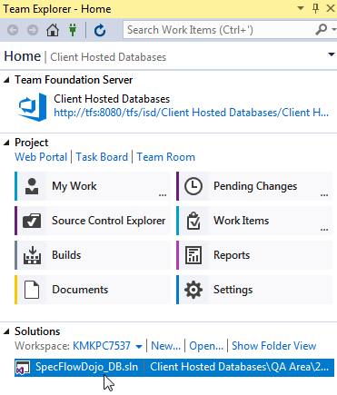

Wait till Solution will be prepared. In *Solution Explorer (View -> Solution Explorer)* window you should see:

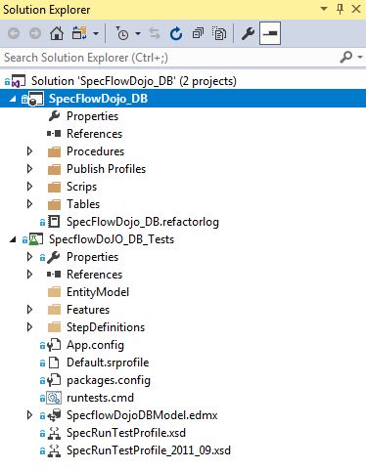

1. Open the App.config file (double-click)

In file find the string “**initial catalog=SpecFlowDojo_DB**” and change **SpecFlowDojo_DB** to a name provided to you by organizers.

1. Right-click on a Solution and select *Restore NuGet Packages*.

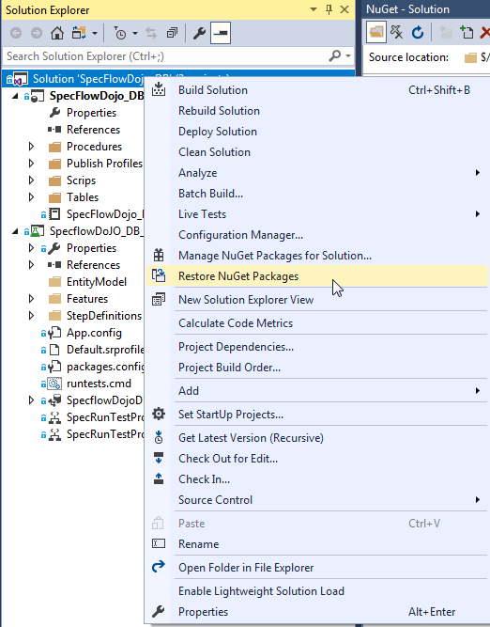

1. When it finishes right-click on a Solution again and select *Build Solution*. No errors should occur.

# Open existing tests

1. Open *Test Explorer* window (*Test -> Windows -> Test Explorer*)

You should see this window as below:

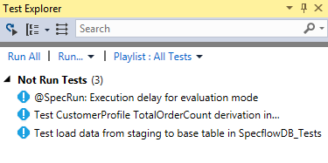

1. Right-click on any desired test (e.g. *PostcodeRegionAndDistrictByPostcodeOX495NU*) and select **Run Selected Tests**

Test should pass if all was OK.

1. You can click on Output link in the bottom to see the output from the future test

